**JunYee (Luis Yee, Jr., 1942-)**

Junyee/Luis Yee, Jr. is a Filipino artist known for large-scale and site specific art installations. He was born in the Philippine island of Agusan del Norte. Trained as a sculptor, Junyee is pioneer of using materials readily available from nature for site-specific works that are expansive, incorporating ephemeral material within specific locations, and redefining site and space in the process. His art is steeped in an awareness of ecology and environmental issues. His inventive use of indigenous material– which he assembles into sprawling constellations of forms, swarms of objects, or networks of points which function like maps– conveys a deep appreciation of nature. For example, his works *Wood Things* (1981) and *Spaces and Objects* (1986) are sprawling assemblies of natural forms. Junyee’s installations bring the precarious state of our natural world to the fore. By incorporating natural objects into his art, he exhibits both resourcefulness and acute awareness of the finite state of natural resources. Junyee’s approach to art is characterised by a keen intuitive sense of the environment and astute knowledge of materials. Whether they are paintings from soot; free-standing and outdoor sculpture in wood or cast concrete; or sprawling site installations, Junyee exhibits a feeling for form and deep awareness of the ways art carves new spaces of experience.

Junyee’s approach is exemplified in his work *Angud*, a 2007 site-specific work at the lawn of the Cultural Center of the Philippines, which incorporated numerous heads of felled trees, the topmost section of the logs drilled with a hole for hauling along forest trails. Junyee formed a matrix on the lawn by stringing red rope through these holes. There emerged a symbolic map of the country’s denuded forests, which the artist also described as ‘graveyard of remains’.

Junyee began to use found objects and material from his surroundings in the early seventies, initially for installations while enrolled at the University of the Philippines’ Diliman campus and later for large-scale pieces fashioned from wood scraps in Los Banos, Laguna a suburb south of Manila. These initial forays were followed by award winning ephemeral works, notable among which was *Wood Things*, installed in a public park in Manila. It was awarded grand prize in the Art Association of the Philippines competition.

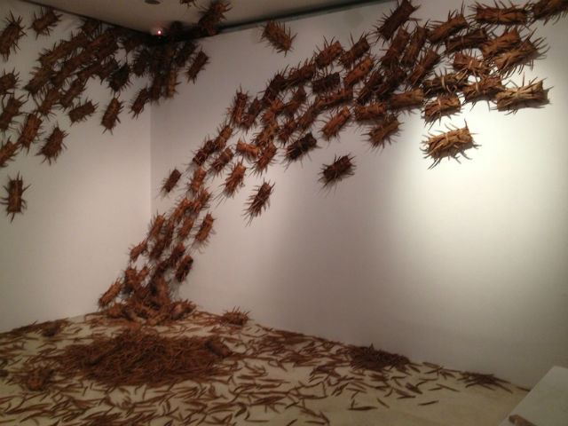

Junyee, *Wood Things*, 1981, Cultural Center of the Philippines. Copyrights to be sought from Cris B. Millado, CCP Artistic Director and Vice President.

Junyee has curated public art events, among them the Movement for Indigenous Art in Havana in 1991 and between 1981 and 1983, the first outdoor installations in the grounds of Mt. Makiling in Laguna. He transformed a 3000-square meter parcel of land inside the University of the Philippines Los Banos into a sculpture garden and is involved in plans to develop the Artists Village in Baler, Aurora province the Philippines.

Junyee’s body of work is multidimensional in scope including painting, sculpture, assemblage, site-specific pieces and large-scale installations. He ventures into the field of design, overseeing work on functional art pieces, landscapes and collaborating with architects to design houses and interiors. Junyee’s contributions are recognised through awards from local culture agencies, the National Commission of Culture and the Arts and the Cultural Center of the Philippines and he has participated in numerous international exhibitions including the 16th Asian International Exhibition in Guangdong Museum of Art China (2001), the 7th Havana Biennale in Cuba (2000), and the First Asia Pacific Triennale in Brisbane Australia (1993).

**References and Further Reading**

Canete, Reuben Ramas. (2012) *Art and its Contexts: Essays, Reviews and Interviews on Philippine Art*. Manila: University of the Philippines Publishing House, 294-296.

Constantino, Marika. (2009) “Cordillera ink: Luis ‘Junyee’ Yee, Jr.’s lifelike tattooed hardwood figures…” *Contemporary Art Philippines*, vol. 3, no. 29.

Guillermo, Alice G. 1994. ‘Luis Enena Yee, Jr.’ in the *CCP Encyclopedia of Philippine Art*, Volume 4: Visual Arts. Pasay City: Cultural Center of the Philippines, 414-415.

Koterbay, Karlota Isla Contreras. 2006. *Constructing the Indigenous: The works and lives of Santiago Bose, Rey Paz Contreras, Roberto Feleo, and Luis ‘Junyee’ Yee, Jr.,* Unpublished thesis, University of the Philippines-Diliman.

**Virtual Sources and Information on Works**

<http://vimeo.com/51039443>

(Interview with JunYee)

<http://www.gmanetwork.com/news/story/357061/cbb/earth-day-2014-at-ccp>

(2014 Earth Day installation at the front lawn of the Cultural Center of the Philippines)

<http://newsinfo.inquirer.net/421283/theres-no-stopping-junyee>

(Newspaper feature on the artist)

<http://www.aaa.org.hk/Collection/Details/49136>

(Asia Art Archive Hong Kong file)

<http://www.galleriaduemila.com/web2003/artists/yee/yeeabout.html>

(Detailed CV with images of some works)